**Suggested sql server videos**  
[**Part 52 - Database Normalization & First Normal Form**](http://csharp-video-tutorials.blogspot.com/2012/09/database-normalization-part-52.html)   
  
   
  
   
  
   
  
In this video will learn about second normal form (2NF) and third normal form (3NF)  
**A table is said to be in 2NF, if**  
1. The table meets all the **conditions of 1NF**  
2. Move **redundant** data to a separate table  
3. Create **relationship** between these tables using foreign keys.   
  
**The table below violates second normal form**. There is lot of redundant data in the table. Let's say, in my organization there are 100,000 employees and only 2 departments (**IT & HR**). Since we are storing **DeptName, DeptHead and DeptLocation**columns also in the same table, all these columns should also be repeated 100,000 times, which results in unnecessary duplication of data.   
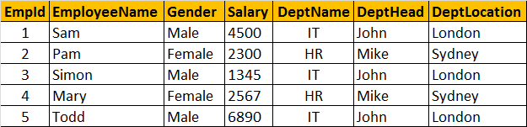  
  
**So this table is clearly violating the rules of the second normal form**, and the redundant data can cause the following issues.  
1. Disk space wastage  
2. Data inconsistency  
3. DML queries (Insert, Update, Delete) can become slow   
  
**Now, to put this table in the second normal form**, we need to break the table into 2, and move the redundant department data (**DeptName, DeptHead and DeptLocation**) into it's own table. To link the tables with each other, we use the **DeptId** foreign key. The tables below are in 2NF.   
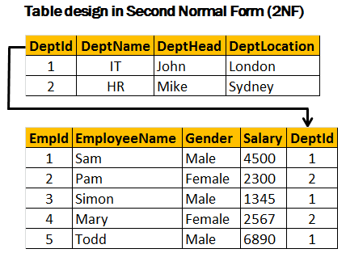   
  
**Third Normal Form (3NF):**  
**A table is said to be in 3NF, if the table**  
1. Meets all the conditions of **1NF and 2NF**  
2. Does not contain columns (attributes) that are not fully **dependent upon the primary key**  
  
**The table below, violates third normal form**, because **AnnualSalary** column is not fully dependent on the primary key **EmpId**. The **AnnualSalary** is also dependent on the **Salary** column. In fact, to compute the **AnnualSalary**, we multiply the **Salary** by **12**. Since **AnnualSalary** is not fully dependent on the primary key, and it can be computed, we can remove this column from the table, which then, will adhere to 3NF.  
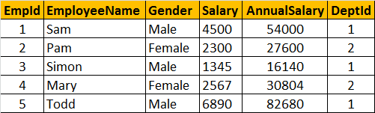   
  
**Let's look at another example of Third Normal Form violation**. In the table below, **DeptHead** column is not fully dependent on **EmpId** column. **DeptHead** is also dependent on **DeptName**. So, this table is not in **3NF**.  
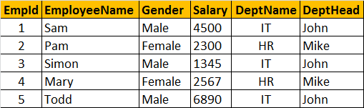   
  
**To put this table in 3NF, we break this down into 2**, and then move all the columns that are not fully dependent on the primary key to a separate table as shown below. This design is now in 3NF.  
